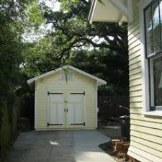
General Guidelines
● Retain and preserve historic garages and outbuildings
whenever possible.
● New buildings should not visually detract from the main house.
● New buildings should be placed behind the front line of the
main house.
● Single-width garage doors maintain the character of historic neighborhoods. Multiple garage doors detract from historic
character
● Carports are not appropriate in Historic Districts as
they were not traditionally the type structures constructed during the period of significance of the district.
● Pergolas are historical garden structures. They are sometimes appropriate for outdoor covered areas.

History
● Garages originally were separate buildings placed behind the house, often accessed from alleys.
● Began to be incorporated into houses in 1920s. Usually place on side of house. In hilly locations
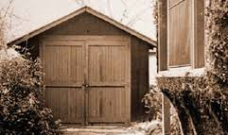
they were often tucked underneath.
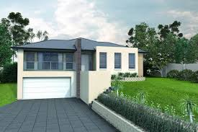
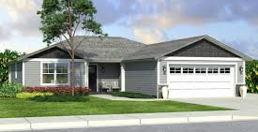
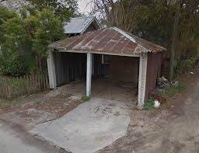

● Garages in Ranch Style houses were under the same roof as main house and often placed in front.
● By 1970, garages were one of the most prominent features of a house. Typically placed closer to
the street, and with wider doors than earlier examples.
● Other types of historic outbuildings include sheds for storing garden/farm equipment, wood sheds, pump houses, spring houses and outhouses.

Placement and Size of New Garages/Outbuildings
● Locate as inconspicuously as possible on side or rear of main house. Preferably placed behind
rear line of main house.
● Must meet current city codes on setback and lot coverage ratios.
● Utilize smaller footprints than main house and limit to one-story in height.
● Follow historic setback patterns of other garages and outbuildings on street or in
district.

● Locate sheds and gazebos in rear yards.
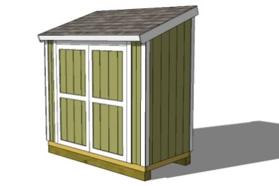
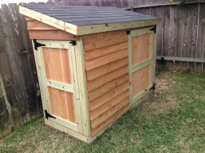
● Screen from public view with landscaping.

Should outbuildings match style of main house?
● Design of new buildings should be secondary to and simpler than that of main house.
● Materials should reflect the use and function of the building, not that of main house.
● Compatibility with historic district and streetscape, not just main house, is
important.
● Use roof form that compliments main house in shape and pitch.
● Metal, plastic, vinyl, plywood or canvas prefabricated outbuildings or
carports are inappropriate and not acceptable.
Wooden, brick or stone outbuildings or sheds are appropriate. They should be inconspicuous.

Garage Doors
● Paint to complement garage.
● Use single width doors. If two-car garage is desired, use separate single-width doors for each bay.
● Metal doors are not appropriate, but if used, they should be painted.
● Overhead wood doors that reflect the character of historic swinging doors are good options.
● If doors are highly visible from a public street, wood paneled doors are preferred.
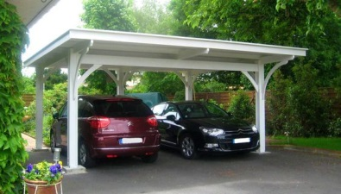
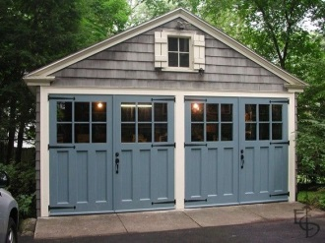
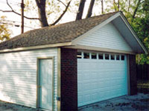
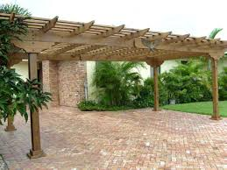
Use single-width doors for each bay. Solid, double-width garage doors are inappropriate. However, they can be designed to appear single-bay.

Wooden pergola-style coverings are often a permitted compromise.

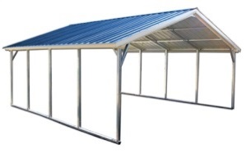
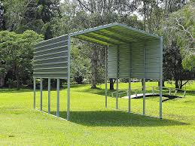
Additional Reading
Metal carports or bus ports are not appropriate for Senatobia's Historic Districts and are not acceptable.

1. National Park Service Preservation Brief No 14: New Exterior Additions to Historic Buildings: Preservation Concerns; www.nps.gov/hps/tps/briefs/brief14.htm

2. National Park Service, The Secretary of the Interior’s Standards for Rehabilitation and Illustrated Guidelines for Rehabilitating Buildings; http://www.cr.nps.gov/hps/tps/standguide/rehab/rehab_approach.htm

